**TASK 1 :**

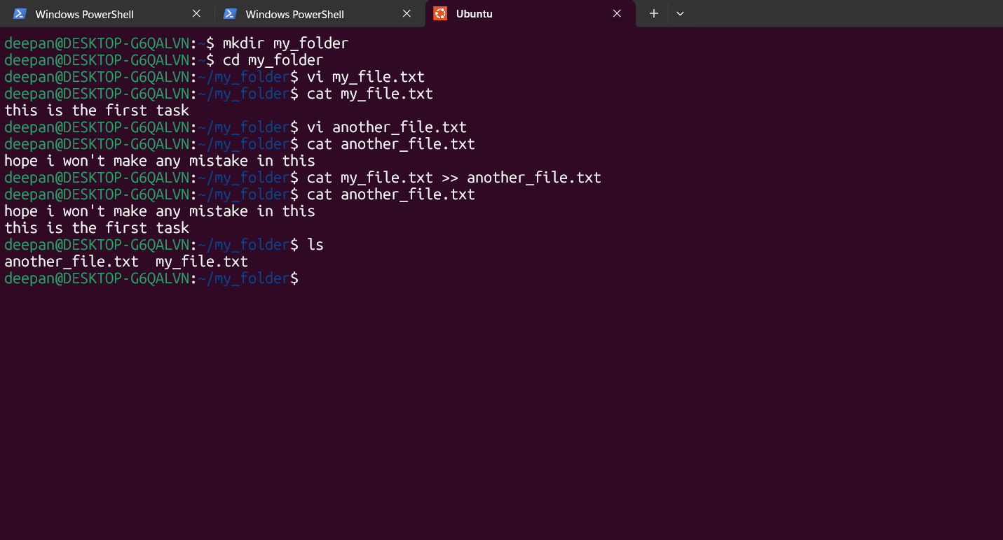

deepan@DESKTOP-G6QALVN:~$ mkdir my_folder

deepan@DESKTOP-G6QALVN:~$ cd my_folder

deepan@DESKTOP-G6QALVN:~/my_folder$ vi my_file.txt

deepan@DESKTOP-G6QALVN:~/my_folder$ cat my_file.txt

this is the first task

deepan@DESKTOP-G6QALVN:~/my_folder$ vi another_file.txt

deepan@DESKTOP-G6QALVN:~/my_folder$ cat another_file.txt

hope i won't make any mistake in this

deepan@DESKTOP-G6QALVN:~/my_folder$ cat my_file.txt >> another_file.txt

deepan@DESKTOP-G6QALVN:~/my_folder$ cat another_file.txt

hope i won't make any mistake in this

this is the first task

deepan@DESKTOP-G6QALVN:~/my_folder$ ls

another_file.txt my_file.txt

deepan@DESKTOP-G6QALVN:~/my_folder$

**TASK 2 : Create a 20 new file  
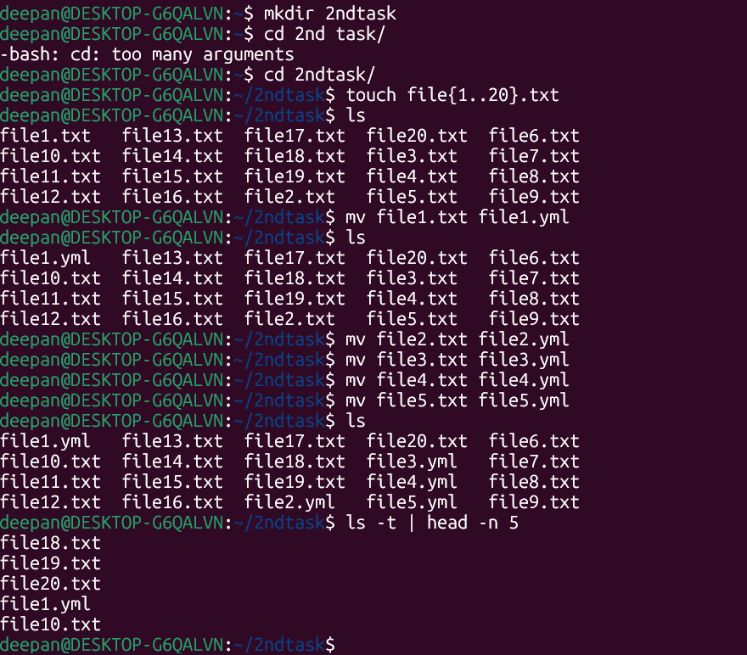**

**TASK 2**

deepan@DESKTOP-G6QALVN:~$ mkdir 2ndtask

deepan@DESKTOP-G6QALVN:~$ cd 2nd task/

-bash: cd: too many arguments

deepan@DESKTOP-G6QALVN:~$ cd 2ndtask/

deepan@DESKTOP-G6QALVN:~/2ndtask$ touch file{1..20}.txt

deepan@DESKTOP-G6QALVN:~/2ndtask$ ls

file1.txt file13.txt file17.txt file20.txt file6.txt

file10.txt file14.txt file18.txt file3.txt file7.txt

file11.txt file15.txt file19.txt file4.txt file8.txt

file12.txt file16.txt file2.txt file5.txt file9.txt

deepan@DESKTOP-G6QALVN:~/2ndtask$ mv file1.txt file1.yml

deepan@DESKTOP-G6QALVN:~/2ndtask$ ls

file1.yml file13.txt file17.txt file20.txt file6.txt

file10.txt file14.txt file18.txt file3.txt file7.txt

file11.txt file15.txt file19.txt file4.txt file8.txt

file12.txt file16.txt file2.txt file5.txt file9.txt

deepan@DESKTOP-G6QALVN:~/2ndtask$ mv file2.txt file2.yml

deepan@DESKTOP-G6QALVN:~/2ndtask$ mv file3.txt file3.yml

deepan@DESKTOP-G6QALVN:~/2ndtask$ mv file4.txt file4.yml

deepan@DESKTOP-G6QALVN:~/2ndtask$ mv file5.txt file5.yml

deepan@DESKTOP-G6QALVN:~/2ndtask$ ls

file1.yml file13.txt file17.txt file20.txt file6.txt

file10.txt file14.txt file18.txt file3.yml file7.txt

file11.txt file15.txt file19.txt file4.yml file8.txt

file12.txt file16.txt file2.yml file5.yml file9.txt

deepan@DESKTOP-G6QALVN:~/2ndtask$ ls -t | head -n 5

file18.txt

file19.txt

file20.txt

file1.yml

file10.txt